Date: 08.09.2023
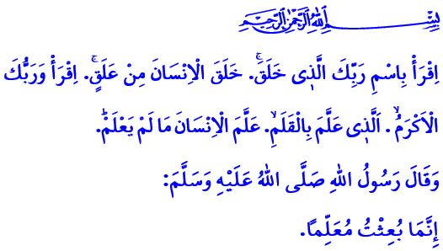
THE PATH OF KNOWLEDGE IS THE PATH TO PARADISE
Dear Muslims!
The first five verses of Surah al-‘Alaq, which I recited at the beginning of the khutbah, are the first verses of the Holy Qur’an to meet humanity. In these verses, Allah the Almighty states, “Read, ˹O Prophet,˺ in the Name of your Lord Who created—created humans from a clinging clot. Read! And your Lord is the Most Generous, Who taught by the pen—taught humanity what they knew not.”
In the hadith I read, the Prophet Muhammad (saw) said, “Verily I have been sent as a teacher.”
Honorable Believers!
According to our sublime religion Islam, learning knowledge is fardh (obligatory) upon every Muslim, man and woman. Knowledge primarily means knowing oneself, the Lord (swt), and one’s environment. It means being aware of the purpose of creation. It also includes reading the existence and the whole universe correctly.
Dear Muslims!
What makes knowledge valuable is that it is for the benefit of humanity. It leads society to justice, truth, and goodness and keeps us away from injustice, oppression, and any kind of evil. The knowledge that causes confusion in minds, corruption of generations, destruction of societies, and damage to our world is worthless and harmful.
Esteemed Believers!
Ignorance is the greatest enemy of Islam. It is the source of all evil. Ignorance makes a person worthless before Allah and in the sight of people. Reading, equipping oneself with useful knowledge, and using knowledge for the good of humanity elevate a person. Allah the Almighty states, قُلْ هَلْ يَسْتَوِي الَّذ۪ينَ يَعْلَمُونَ وَالَّذ۪ينَ لَا يَعْلَمُونَۜ “Say, ˹O Prophet,˺ ‘Are those who know equal to those who do not know?’” In another verse, those who have true knowledge are praised as follows: “Of all of Allah’s servants, only the knowledgeable ˹of His might˺ are ˹truly˺ in awe of Him.”
Respected Muslims!
The path of knowledge is the path to paradise. Our beloved Prophet (saw) said, “Whoever takes a path upon which he seeks knowledge, then Allah makes the path to Paradise easy for him.” Today, if we embrace knowledge with the same awareness as in the past, and if we use the possibilities of science and technology appropriately, we can give a new direction to humanity. If we reflect the power of the pen and the word in our lives, we can make justice and goodness prevail on earth again. If we make knowledge and wisdom our guide, we can be the hope again in today’s world where divine and human values are being degraded and neglected. But if we distance ourselves from knowledge and wisdom, and use knowledge and technology for other purposes, we will drift into a disaster. In that case, humanity cannot escape the darkness of oppression and injustice, and the vortex of violence and unrest that it is in today.
Dear Brothers and Sisters!
The new academic year begins next Monday. Millions of our children will meet the schools that are the home of knowledge and wisdom. It is the common duty of all of us to raise our children as generations who are loyal to national and moral values, and who are beneficial to their nation and humanity. So let us raise our children, the light of our eyes, with the knowledge horizon that Islam commands, as believers whose minds, feelings, and actions are in balance with each other. Our method of educating our children should be the verse, اُدْعُ اِلٰى سَب۪يلِ رَبِّكَ بِالْحِكْمَةِ وَالْمَوْعِظَةِ الْحَسَنَةِ “Invite ˹all˺ to the Way of your Lord with wisdom and kind advice.” And our main goal should be to raise our children with the beautiful morals of our beloved Prophet (saw) who said, إِنَّمَا بُعِثْتُ لِأُتَمِّمَ صَالِحَ الْأَخْلَاقِ “I have been sent to perfect good moral character.” On this occasion, I pray to Allah the Almighty that the new academic year brings good to our children, teachers, families, and our nation.
Dear Muslims!
As I conclude my khutbah, I would like to share one more point with you. The Qur’an courses for children ages 4-6 will start next Monday. All Qur’an courses will open on September 18, and registration is ongoing. Besides, online classes will be organized for our brothers and sisters who will not be able to attend the courses. We welcome our children, youth, women, and men of all ages to our Qur’an courses, where authentic religious knowledge is taught.
I conclude my khutbah with the following hadith of the Prophet Muhammad (saw): “Either be the teacher, or the learner, or the listener, or the one who supports knowledge. Do not be the fifth, or you will perish!”

‘Alaq, 96/1-5.
Darimi, Muqaddimah, 32.
Zumar, 39/9.
Fatir, 35/28.
Tirmidhi, ‘Ilm, 19.
Nahl, 16/125.
Ibn Hanbal, II, 381.
Darimi, Muqaddimah, 26. General Directorate of Religious Services

